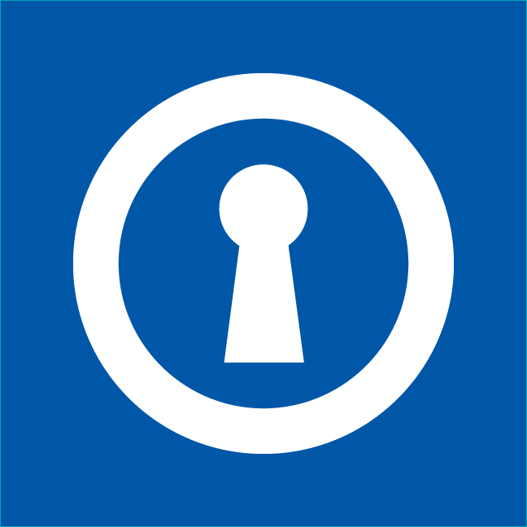

SECRET ART SALE
South Shore Center
January 27-29, 2017

Thank you very much for your willingness to participate in the upcoming Frank Bette Secret Art Sale January 27 – 29, 2017. We also thank your students in advance for their contribution of 5”x7” art which will be exhibited at The South Shore Center as described below:
Drop off the artwork to The Frank Bette Center for the Arts, 1601 Paru Street, Alameda, January 13-15, 2017 (11:00am to 3:00pm) or make other arrangements by email: admin@frankbettecenter.org
Preview and purchase art: Friday from 3:00 pm to 7:00pm, (January 27th) and Saturday and Sunday from 11:00 am to 5:00pm (January 28th and 29th) at The South Shore Center (specific location TBD).

As a reminder, the artwork must be signed ONLY on the back to keep the artists’ identity a secret. The artwork will be displayed and sold for $20 each throughout the event. The “secret” will be revealed at the end of the exhibition when the art collectors discover whether they have invested in a valuable piece of art from a well-known artist or celebrity or a masterpiece from a talented student artist.
For instructions on submitting your work, please see the following guidelines:
For additional information or questions please contact Mark Schwabl at admin@frankbettecenter.org or visit our website at: http://www.frankbettecenter.org/secret-art-sale.html
Thank you, The Frank Bette Secret Art Sale Team
ART WORK SUBMISSION GUIDELINES
- Submit your original artwork on any heavy weight (140 lb or heavier) watercolor paper or photography paper as long as it is presented in a 5”x 7” size. Alternatively, the Frank Bette Center for the Arts will be pleased to provide you with paper should you require it (please contact us at admin@frankbettecenter.org). Paper can be picked up at the Frank Bette Art Center, 1601 Paru St. Alameda.
- Please do not frame, matt or attach hanging hooks, wire etc.
- Any medium may be used (paint, pencil, ink, charcoal, collage, photography, etc.) May be two-dimensional or three-dimensional (as long at it is not heavy).
- Each student artist may submit one to five pieces, each of 5”x7” in size. We may be rotating more pieces in as ones are sold.
- Students: print and sign your name (first name, middle and last initials) on the back of your artwork and include School name. Do not sign on the front (to keep your identity a mystery).
- Drop off the artwork to The Frank Bette Center for the Arts, 1601 Paru Street, Alameda, January 13-15, 2017 (11:00am to 3:00pm) or make other arrangements by email: admin@frankbettecenter.org
- All submitted artwork will be displayed alongside the professional artists and celebrities work at The South Shore Center January 27th (3:00 pm -7:00pm) and January the 28th and 29th (11:00am-5:00pm) Hope you can make it!
- The artwork will be available purchase for $20.00 throughout the exhibition.
- All purchased art MUST be collected upon purchase.
- Any unsold student art will be returned to the respective schools or may be picked up after the show at the Frank Bette Center through the month of January. Teachers may want to create an inventory of their students art pieces at the time of art drop off to determine what student pieces were sold..

