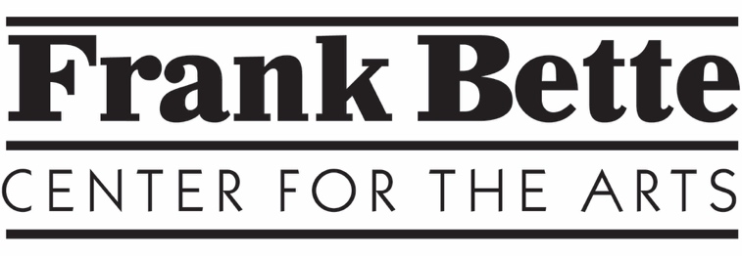

Signature Gallery Prospectus

The Signature gallery in the Frank Bette Center for the Arts (FBCA) is located in a separate space from the Main Gallery and offers private exhibits administered separately from the Main Gallery. There are generally six one-month shows a year in the Signature Gallery: February, March, June, July, October and November/December. Signature gallery exhibits coordinate dates with Main Gallery exhibits and begin the first Friday of the month. Opening Receptions are held the second Friday of the month. After the exhibit, art is picked up on the last Sunday of the month. This arrangement may be adjusted by Signature gallery curators, who jury and oversee the Signature gallery exhibits.

APPLICATION PROCESS: Applicants for Signature gallery exhibits may be invited by curators, be recommended by Frank Bette members, or contact the gallery to express their interest. However, interest or recommendations are not guaranteed of acceptance. Signature gallery curators select artists based on perceived artistic quality. In general, the content of each exhibit must be suitable for family viewing express creativity, originality and professionalism.

All exhibited art must be for sale and artists set the prices for their work. Solo exhibitors must be current members of FBCA. For exhibits featuring multiple artists, one artist must be a current FBCA member.

ACCEPTED ARTISTS:
Entry Fees. For monthly exhibits, entry fees are as follows:
Solo artists: $50
Multiple artists: $25 per artist

Commissions: Exhibiting artists receive 60% of the retail price of all artwork sold. FBCA receives 40% of the artwork price. Artists are paid within 31 days of the close of the exhibit.

Hanging the Artwork

Artists are expected to layout artwork for hanging. They will coordinate with curators to install according to gallery guidelines. Exhibited art must be framed or have finished edges and ready to hang with D-rings for stringing. No nails or other hanging materials may be placed on walls or doors in the Signature Gallery. The room should be left in the same condition as it was found.

There are four walls available for two-dimensional work. Two and three-dimensional work can be placed on the top of the table storage cabinet.

Artwork identification labels must be attached to the lower left corner on the back of each piece of art. The label will include the artist’s name, item number, title, medium, and price. If duplicate items such as cards are part of the exhibit, they too must be numbered.

A numbered inventory sheet needs to be completed to identify all artwork.
Artist statements should be placed on a small easel on top of the cabinet for viewing.

Advertising

- FBCA produces postcards for Main and Signature gallery exhibits. Artists must provide a the highest-resolution jpeg they have for this purpose, as well as the banner to be placed on the outside of the building.

- A monthly ad is placed in the Alameda Sun, which will include Main and Signature Gallery exhibits.

- The exhibit is featured on the FBCA website and in the Monthly and Class newsletters.

- Artists are encouraged to do additional advertising for the exhibit (mailing lists, social media, etc.). Advertising should include the Frank Bette Center for Arts logo (available upon request). Contact: communications@frankbettecenter.org.

Link to Signature Gallery Forms:
The following materials are available on
https://www.frankbettecenter.org/signature-gallery.html

- Application form- submit to curator BZ Meyers signaturegal@frankbettecenter.org
- Artwork will be juried

Accepted artists:
- Submit Entry fee(s)
- If you are not a member join here: https://www.frankbettecenter.org/store/c7/Membership.html

Download these files:
- Signature Gallery Prospectus
- Signature Gallery Agreement form
- Artist inventory
- Signature Gallery Floor Plans
- FBCA Labels for back of the art

